GIT Branching

Objective: Commit HTML, CSS & JavaScript assignments into GIT.

SECTION-1 (HTML assignments) - Steps to follow:

21. First take a backup of your assignments & projects. This is required because due to incorrect GIT operation you may lose your files.

22. Create an empty directory Assignments' & cd to "Assignments'.

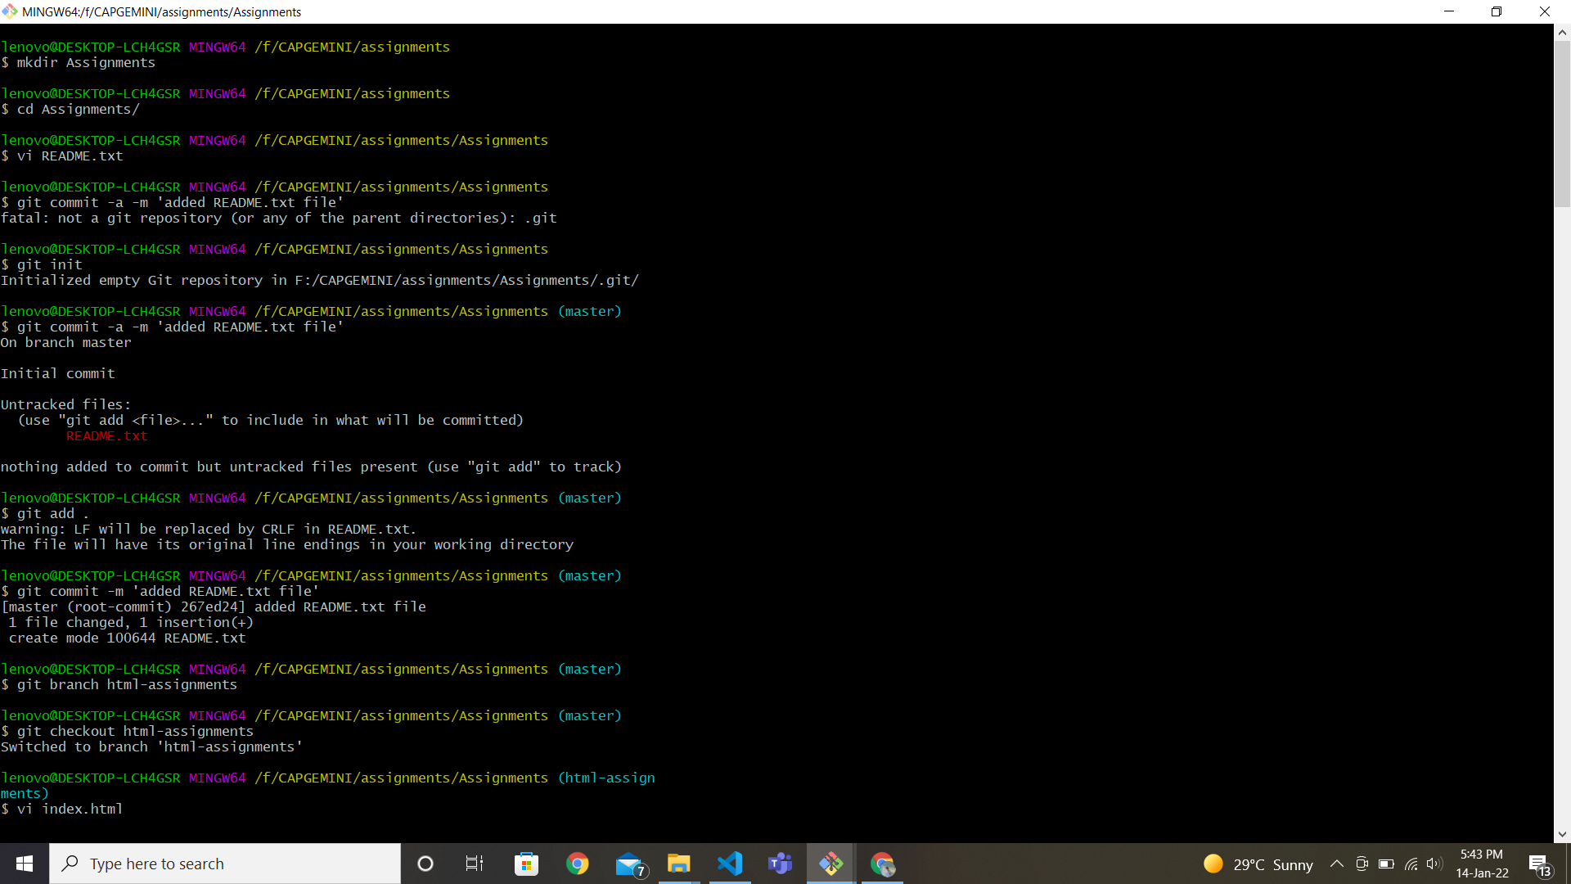

23. Create a file README.txt inside Assignments' & write few lines about the contents of Assignments' folder.



24. Commit README.txt file.



25. Now create a new branch 'html-assignments'.



26. Switch to html-assignments' branch.



27. Copy all HTML assignments inside 'Assignments' folder.



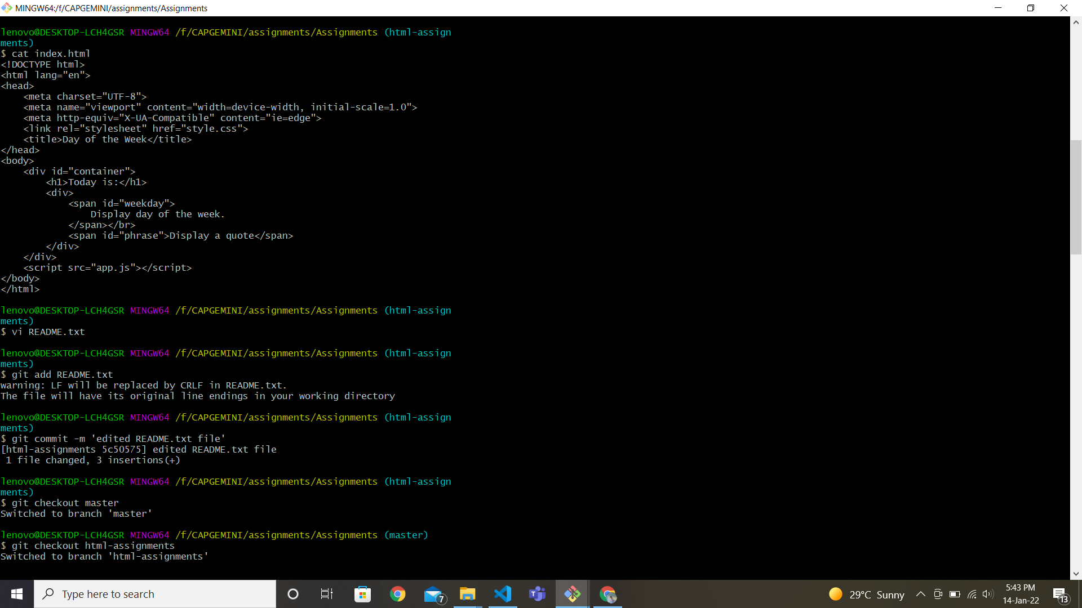

29. Make minor changes into few files belonging to 'html-assignments' branch.



30. Commit those changed files.



31. Switch to master branch.



32. Make minor changes into README txt file & commit those changes into master.

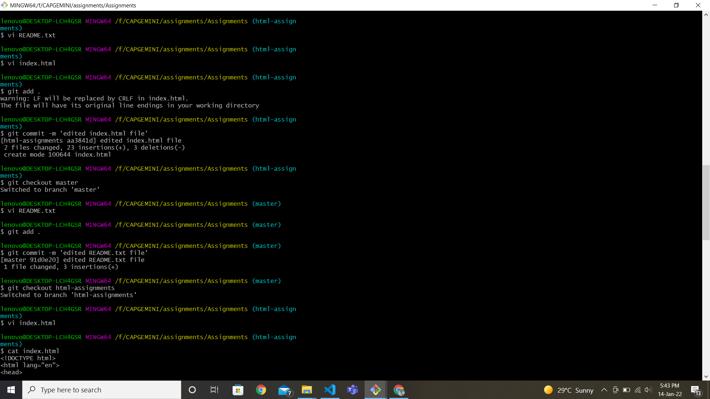

33. Again switch to 'html-assignments' branch.



34. Make minor changes into few files belonging to 'html-assignments' branch.



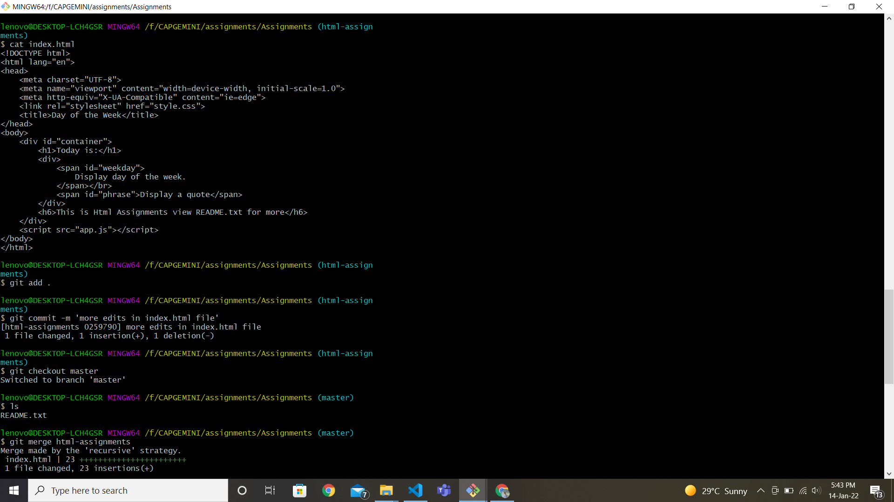

35. Commit those changes.



36. Switch to master.



37. Merge 'html-assignments' branch into master. Confirm all html assignments are shown in master.

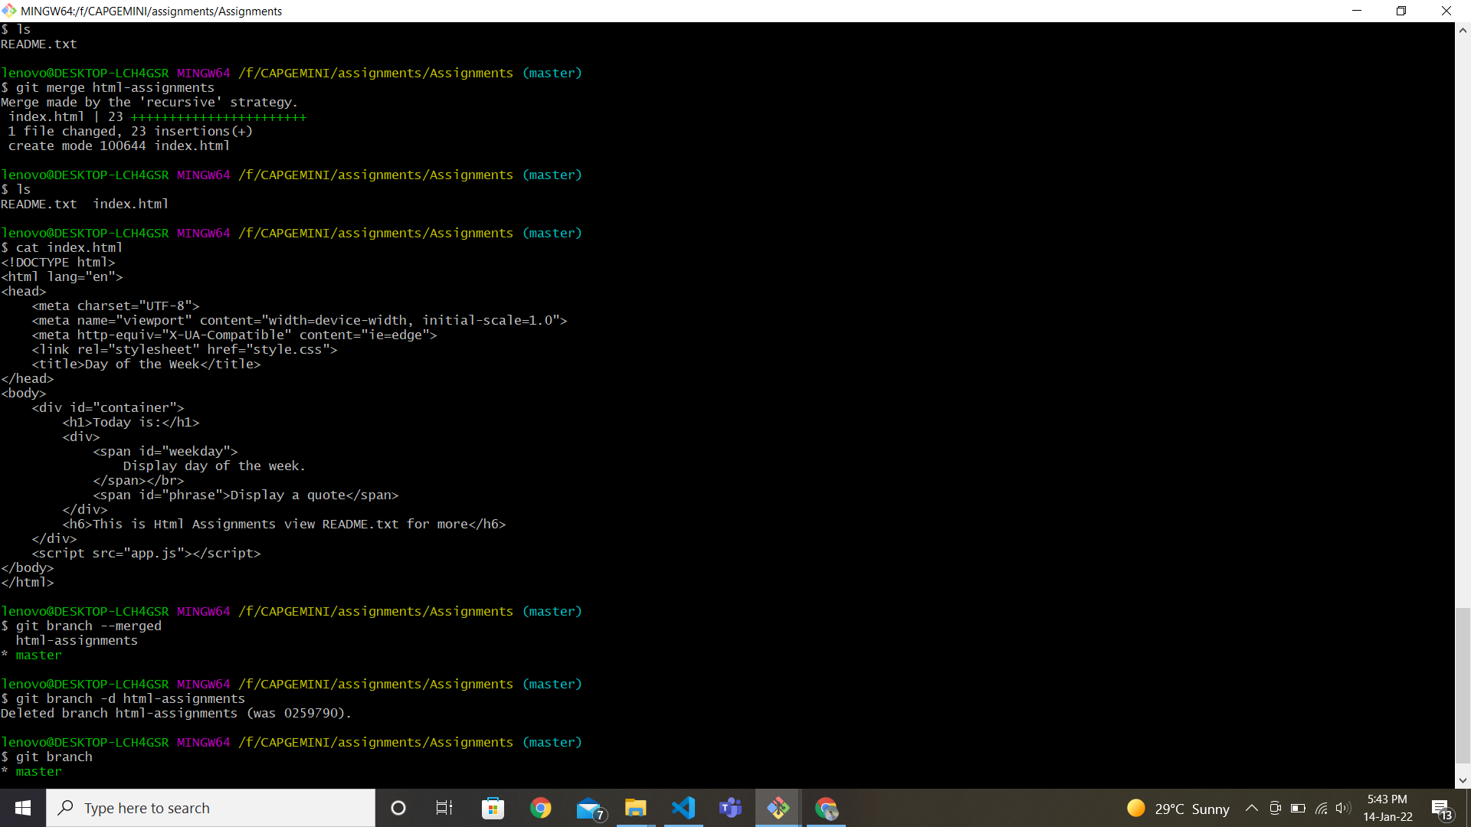

38. Finally delete the "html-assignments' branch.

